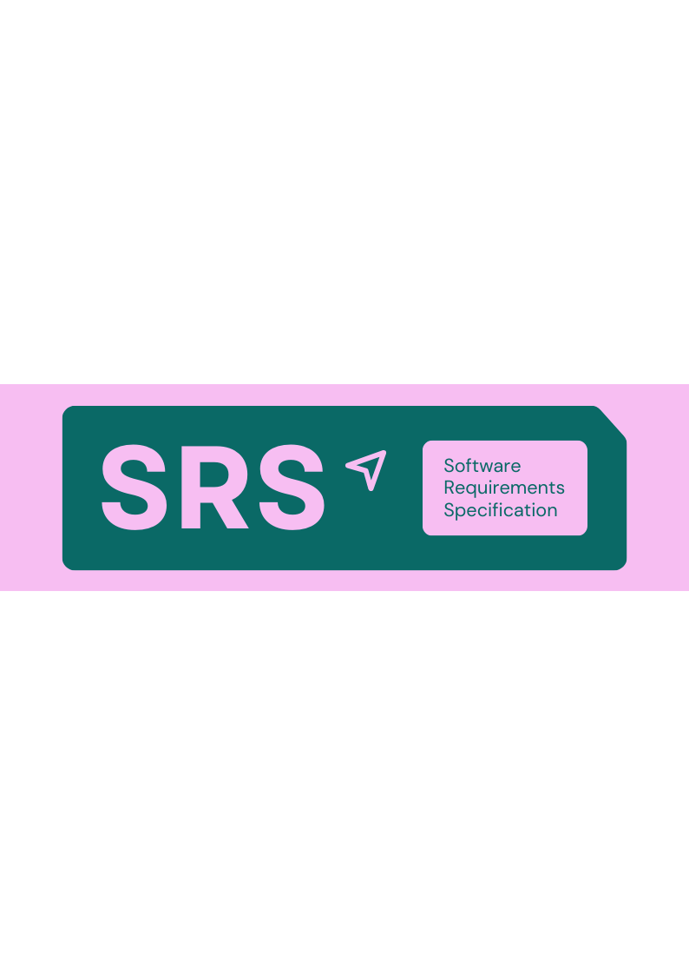

|  |  |  |
| --- | --- | --- |
| **Project name:** Howse | **Prepared by:** Ahmed Imad Tarq | **Live version:** 1.0 |

|  |  |
| --- | --- |
| **1. Introduction** |  |

**1.1 Purpose**

This document describes the requirements of Howse platform , User flow , data base schema and more.

**1.2 Scope**

Howse is a platform that where you can **found** or **sell** the best fit real state for you with the fastest and best way.

|  |  |
| --- | --- |
| **In scope**   * Platform for all end customer * 3D service for end customer * Management System for owner | **Out of scope**   * . |

**1.3 Definitions**

|  |  |
| --- | --- |
| **Administrator** | Application Programming Interface – a set of rules that allows different software components to communicate. |
| **Contractor** | Some user who want to sell its own house |
| **Agency** | Real Estate Office, dealer , residential complex |
| **Buyer** | The end customer |

|  |  |
| --- | --- |
| **2. Overall description** |  |

**2.1 Product perspective**

It’s a service that come up to the realstate market with a new and modern tech in pourbes to feed the Iraqi market for its huge gaps , fast growth and market probleems , by using the most new tech services in this market ( matterport ) and the local market as a beging.

**2.2 Product features**

|  |  |  |
| --- | --- | --- |
| **platform**  The all avail realstates | **Tech service**  Offering Added value | **Profile and Mangment**  Custom more than on realstate in one place and mange them |

**2.3 User classes and characteristics**

|  |  |  |  |
| --- | --- | --- | --- |
| **User class** | **Description** | **Experience level** | **Frequency of use** |
| **Administrator** | Mange the all system | Advanced | 🟢 High |
| **Contractor** | How is sub to the lower paln | Low | 🟢 Low |
| **Agency** | … | High | 🟢 Low |
| **Buyer** | Login register , bowers | Medium | 🟢 High |

|  |  |
| --- | --- |
| **3. Functional requirements** |  |

**3.1 User registration**

* The user enter its information.
* Click send OTP.
* Enter the code.
* Register.

**3.2 Login**

* Enter credentials.
* Redirect depends on has role.

**3.3 password reset**

* Received OTP.
* Enter new password with the OTP.

**3.4 Profile management**

* Change information.

**3.5 3D tour Service**

* Ifram to show.
* Create , edit, Delete by external service app.
* Delete internally .

**3.6 Sub**

* Created by Sub to an avail plan.
* Read, Update, Delete ( By Admin ).

**3.7 management By admin**

* User CRUD and Deactivating
* Palns CRUD
* Categories CRUD

**3.8 Curency management**

* CRUD.

**3.9 Rents offers**

* CRUD by the owner or administrator.
* It can depend on the duration of date or a total minutes as time.

**3.10 property Mangment**

* Created by Sub to an avail plan.
* Read, Update, Delete ( By Admin ).

**3.10 saves**

* CRUD.

|  |  |
| --- | --- |
| **4. External interface requirements** |  |

|  |  |
| --- | --- |
| **4.1 User interfaces** | • Web dashboard  • Mobile Provided by the external service |
|  | |
| **4.2 Software interfaces** | * OTP service (IQOTP) <https://docs.otpiq.com/> * 3D tour Service (Mattport) <http://matterport.com/developers?srsltid=AfmBOoppnLb2rD7q7SrQYyqomcYa4_Ri4NqIE5KEcok9RrqRioemoqbP> * Payment service (WAYL)  <https://api.thewayl.com/reference> |
|  | |

|  |  |
| --- | --- |
| **5. Non-functional requirements** |  |

|  |  |
| --- | --- |
| **5.1 Performance requirements** | 1000 concurrent users  50 Image X 2 Floor X 500 tour = 50 000 Total Images |
|  | |
| **5.2 Safety requirements** | External Service limite |
|  | |
| **5.3 Security requirements** | * Passwords must be hashed. * Role-based access control must be implemented. |